Name : Januth Aditha Abeysinghe

Unit : SIT725 - Applied Software Engineering

Task : 5.2P

Screenshots :
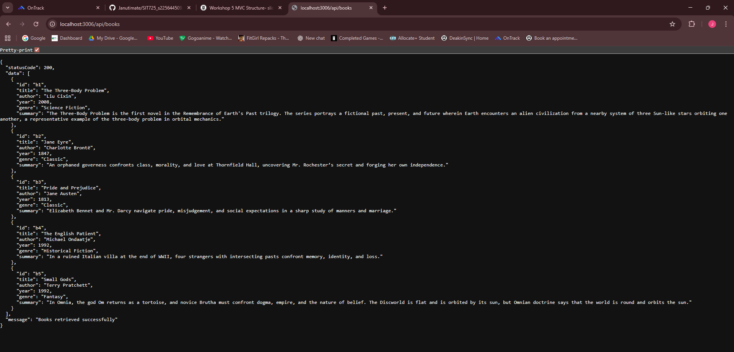
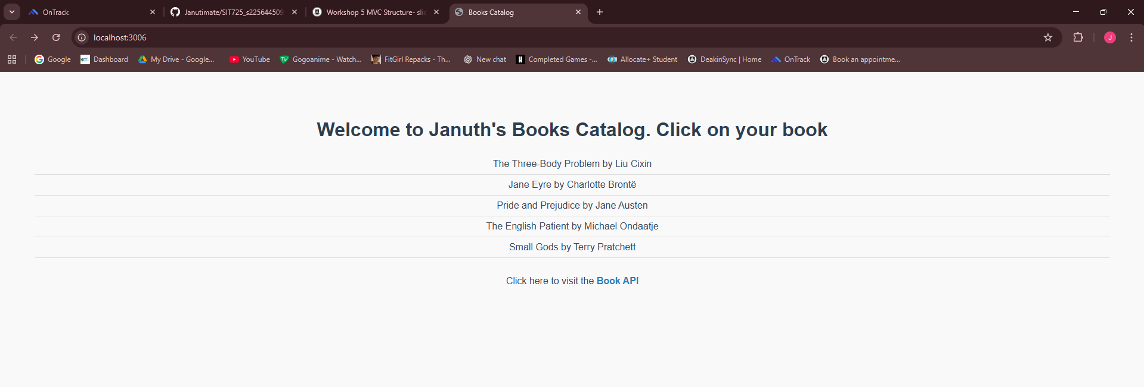
JSON of a single book :

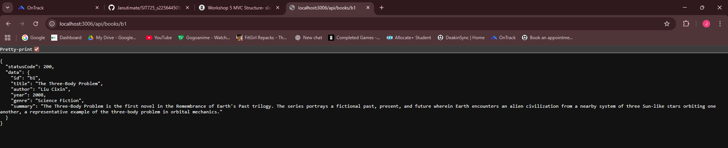

Code :
